Coursera Applied Capstone
Recommendations on Opening a Korean Restaurant in the Region of Toronto

By: Yae Whan Lee

Introduction and Recommendation

Toronto is a city that prides itself with diversity. It is an amazing place where people can enjoy life and multiculturalism. With the advent of globalization, the borders between countries have gradually fallen and led to an opportunity where people can move and immigrate to other countries. In light of this, many foreigners have begun to open restaurants that are linked to their own ethnicity. This has allowed for residents in Toronto to enjoy a diverse option of cuisines, allowing them to be more open to other cultures and lifestyles.

Korean food has recently boomed due to the influence of K-pop and other forms of cultural power. For instance, Korean barbeque is now one of the most popular foods due to the spread of K-drama. With an increased awareness, the demand for Korean cuisine has increased. Consequently, the number of Korean restaurants has also increased in many foreign nations. Therefore, it is vital that newcomers of the Korean restaurant owners must strategize their location and the nearby competitions of the region

Identifying the Problem & Audience

Although it may seem like a common knowledge, finding a suitable location for a restaurant is essential for a high revenue. If the restaurant is able to sustain their popularity through a specialized menu or high quality/low price, finding the perfect location is something that should still be prioritized. The current problem lies in the sense that there are many different Korean restaurant within Canada, especially in cities that have a dense population. Therefore, finding the best location through the analysis of data would be highly recommendable.

The audience would be limited to those who wishes to open a Korean restaurant within Toronto

Data and Methodology

In order to find the best location, I will be using sources which provide data on the neighborhood’s location and names, as well as the restaurants that could potentially threaten the uniqueness of the Korean restaurant. This can be done by gathering the list through online encyclopedias and using the Geocoder package, as well as the Foursquare API.

In this case, I collected the list of neighborhoods from Wikipedia and created into a dataframe to collect data regarding the postal codes, neighborhood names, and so on. Using the Foursquare API, I was able to find the venues in Toronto to allocate markers in their respective areas. I have set the radius quite low in order to further make a more precise and detailed approach. It seems like it did not matter too much anyways. By using one of the categories of Foursquares, “Korean Restaurant”, I was able to find all the venues which was categorized as Korean. Finally, analyzing the amount of relevant restaurant in the area, I could recommend a suitable location for a new Korean restaurant.

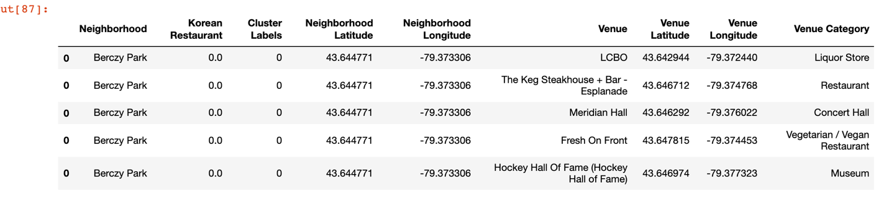

By merging multiple dataframes to unify a single frame with all the necessary information, I could create 3 different clusters which show the number of Korean restaurants in the different regions.

Evaluation

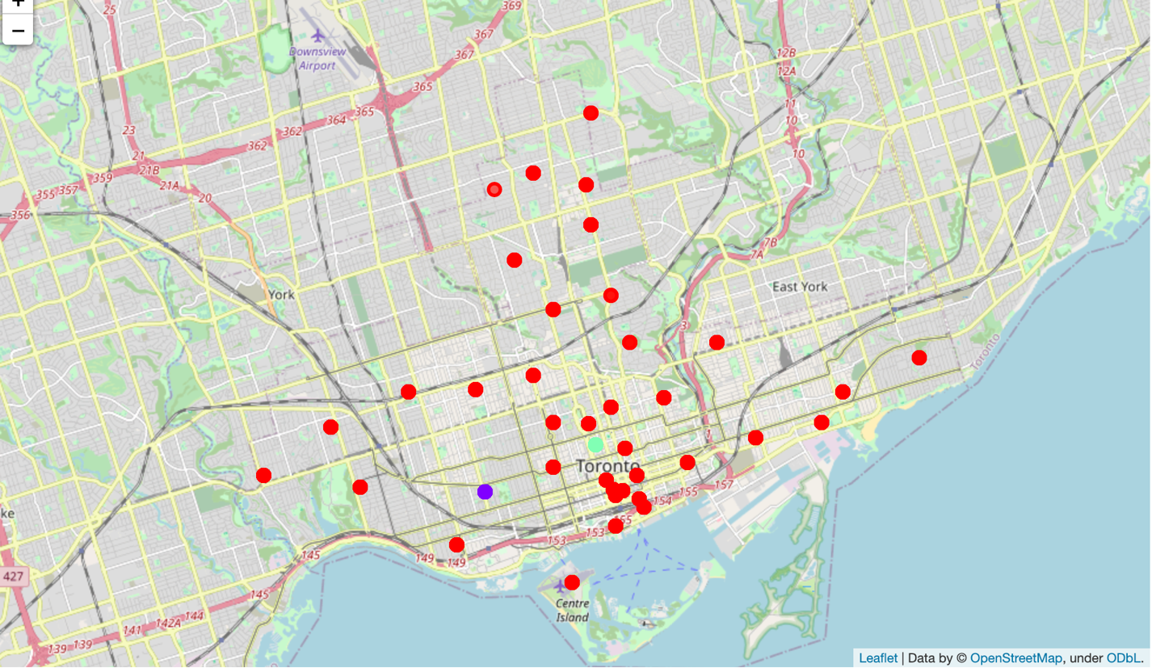

In this case, we can see that cluster 0 and 1 had only one point meaning there are very little Korean restaurants in that region. Meanwhile, cluster 2 had an abundance of Korean restaurants which could mean that cluster 2 has a lower chance of success due to higher level of competition in the regions.

Therefore, the best areas to Richmond, Adelaide, King and Little Portugal, Trinity are the best places to open a Korean restaurant. Low numbers of competitors could mean that people have limited options when going to a unique place. Higher price and popularity could also follow through.

However, it is important to note that this only takes into consideration the number of Korean restaurants. We might miss the ethnicity of a region which could implicate their affinity to Korean food. Also, an area where lots of Koreans are residing could also mean a higher popularity of Korean food.

Overall, this project could ultimately benefit those who are willing to open a Korean restaurant in Toronto.

